

**Open the Roof Scholarship Application**

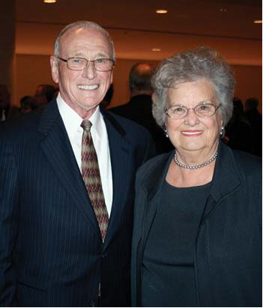

The Open the Roof Scholarships are awarded in honor of the late Jama and Wallace Fowler. In 2023, Megan and Gabe Roberts started the Open the Roof Fund to honor their grandparents (Jama and Wallace Fowler). These scholarships are provided for students attending Jonesboro High School who are prospective first generation college students.

Wallace and Jama Fowler moved to Jonesboro in the mid-1960s. They had three sons and many grandchildren who graduated from Jonesboro High School. In 1969, the Fowlers sold their furniture store and shifted focus to the food industry, specifically KFC restaurants. Together with other relatives, the Fowlers eventually owned 93 franchises. Wallace and Jama also owned and operated multiple banks headquartered in Jonesboro from the 1980’s until 2012. These banks included First Bank of Arkansas, Bank of Jonesboro, Mercantile Bank, and Liberty Bank of Arkansas. In 2011 Wallace was inducted into the Arkansas Business Hall of Fame and in 2020 he received the Legacy of Leadership Award from Arkansas Business.

Scholarship Information: Beginning in 2023 the Open the Roof Scholarship is given to five recipients per semester. The Scholarship covers the cost for one college concurrent class for a Jonesboro High School student.

Purpose: The goal for these scholarships is to give 100 students over a 10 year period the opportunity to determine if college is the best choice for them while still attending Jonesboro High School.

Eligibility: The recipient of this scholarship must be currently enrolled at Jonesboro High School and currently enrolled in a concurrent college course.

Manner of Selection: The scholarships are given to five students per semester.

Amount of Scholarship: The Scholarship pays for one college concurrent course while attending The Academies at Jonesboro High School ($120)

Return Application to: Shatel Gains, BCAL Counselor at the Academies at Jonesboro High School

**Open the Roof Scholarship Application Form**

*Please return this form to*

*The Academies at Jonesboro High School, Shatel Gaines, BCAL Counselor*

*Be sure to include: Personal Statement and Application Form*

Student’s Name:

Student’s Address:

Student’s Phone:

Student’s Email:

Parent’s Name:

Parent’s Address:

Parent’s Phone:

Parent’s Email:

First Generation College Student: Y/N

GPA:

Current Class Rank:

Current Grade:

Current Academy:

ACT and/or SAT Score:

College you plan to attend:

Planned major:

Number of years enrolled in Jonesboro Public Schools:

Other scholarships received so far, including amount: